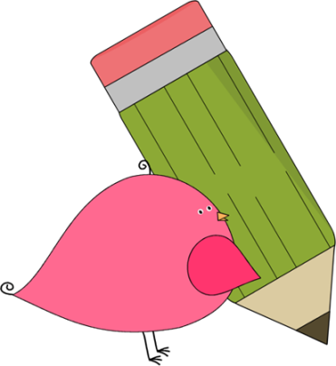

3rd Grade Happenings

September 26th, 2014

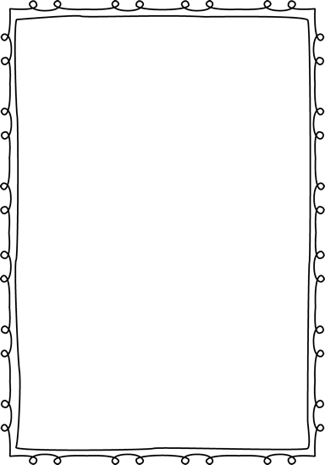



In class this week:

**Writing:** Writing workshop is in full swing! We started off the week talking about what good writers do and do not and finished by looking at strategies for good spelling.

**Math:** This week we were busy! We finished up looking at place value and addition (your child’s quiz should be in the Friday folder), and started looking at subtraction.

**Social Studies:** Our unit on Government ended this week. Look for the quiz to come home next Friday. Thanks for helping your child study!

.

From Mrs. Hunter:

It was WONDERFUL to see so many faces at Prairie Dog Pride Night!! If you weren’t able to attend, never fear, I’ve stuffed the papers I gave out into your child’s Friday folder. ☺

We are in need of 2 liter bottles (empty) for a science experiment. If you have any, please send them in ASAP. Thank you!!!

We’ve had TONS of problems this week with hitting and inappropriate physical touch. We’ve discussed this in class but please remind your child about the importance of keeping a safe body. Now that we’ve discussed this, the consequence for these actions will be loss of recess.



Important Dates and Upcoming Events:

* Sept 29: No School (Teacher Workday)
* Oct 6: PTA Mtg @ 6:00 pm
* Oct 10: Grandparents Day 1:00-2:30
* Oct 23: School Picture Retakes



Want to know more?

Check out our class blog and website!

Website: Mrshuntertmp.weebly.com

Blog: Mrshuntertmp.blogspot.com