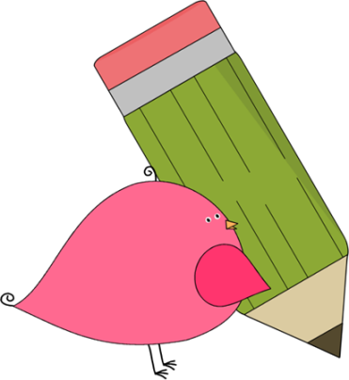

3rd Grade Happenings

October 3rd, 2014





In class this week:

**Math:** Take a look at your child’s quiz from our addition and place value unit. This shows their progress up to this point. We’ve now started subtraction and the difficult task of subtracting across zeroes. Students are doing VERY well!

**Science:** We’ve taken a hiatus from Social Studies to look at weather. First we’re going to study temperature, wind speed, and precipitation and make our very own weather instruments. If you’ve got any empty two liter bottles, please send them our way.

From Mrs. Hunter:

It’s finally fall! So excited for the beautiful fall weather and all the good things that come with it (even the torrential downpours!)

Grandparent’s Day is just around the corner and we are very excited! We’ve got a lot of great things planned. A grandparent or any other special guest is welcome to attend. The festivities are from 1:00-2:00 on October 10th.

After we’re done, your child is welcome to go home with their special guest if you’d liked. Just send in a note on or before Friday.

Don’t forget the Book Fair is next Thursday and Friday as well!



Important Dates and Upcoming Events:

* Oct 6: PTA Mtg @ 6:00 pm
* Oct 9-10: Book Fair
* Oct 10: Grandparents Day 1:00-2:00
* Oct 23: School Picture Retakes



Want to know more?

Check out our class blog and website!

Website: Mrshuntertmp.weebly.com

Blog: Mrshuntertmp.blogspot.com