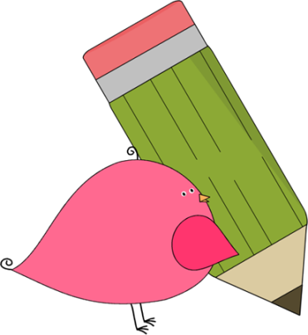

3rd Grade Happenings

October 31st, 2014





In class this week:

**Health:** We have started a brand new unit in health all about germs and diseases. The students are fascinated by it already! We’ve started out by looking at infectious and noninfectious diseases and next week we’ll take a look at how germs spread.

**Writing:** Our children’s books are nearly finished and let me tell you, they look great! So far they’ve been typed and printed, all we need to do now is finish the cover and the illustrations. We’re hoping to share them with some K/1 students soon.

**Math**: The students did a great job on their trimester assessment. Next stop: Multiplication!

From Mrs. Hunter:

Wow!! What an amazing Halloween party! Thank you so much to everyone that helped out. I’m not sure what I’d do without such great parent support.

Thanks especially to Kristi Story for being the party coordinator. We are still in need of coordinators for the Winter and Valentine’s party. Email me if you’re interested.

Please remember to be reading with your child every day and making sure that they’re getting their homework done. It really takes support from both sides to make the best possible learning environment. Thanks for all you do.



Important Dates and Upcoming Events:

* Nov 3: PTA Mtg @ 6
* Nov 4: No School (Teacher Workday)
* Nov 13-14: Parent/Teacher Conferences
* Nov 14: No School



Want to know more?

Check out our class blog and website!

Website: Mrshuntertmp.weebly.com

Blog: Mrshuntertmp.blogspot.com