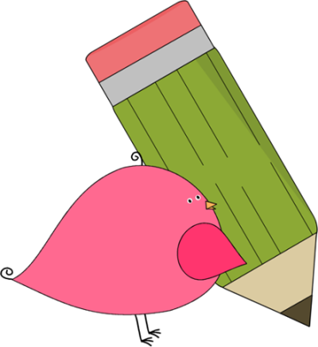

3rd Grade Happenings

October 10th, 2014

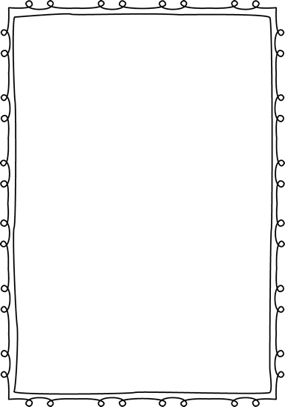



In class this week:

**Math:** We started this week with a math assessment on subtraction. This was real world based and a great look into their mathematical thinking. We went on to look at both metric and standard units of measurement.

**Science:** We had fun making our rain gauges! It just figures that now it has stopped raining! ☺ We also studied and made a flip book of the different types of clouds and researched tornado safety. Whew! We were busy! Our health unit on diseases starts next week.

**Writing:** We have continued our study of narrative writing by researching famous pieces.

From Mrs. Hunter:

What a week! As always we’ve been very busy! It feels like we’ve really hit our stride!

Make sure that your child is still reading 10-15 minutes every night. I gave out a sheet at the beginning of October to record their reading minutes. **This is considered homework and must be turned in at the end of the month.**

Thank you to everyone who took the time to go to the room parent meeting. **Special thanks to Kristi Story who volunteered to be our head room parent for the Halloween party.** See the note in the folder for more details.



Important Dates and Upcoming Events:

* Oct 20: Fundraiser packets due.
* Oct 23: School Picture Retakes
* Oct 31: Halloween Parade/Party 1:30
* Nov 3: PTA Mtg @ 6
* Nov 4: No School (Teacher Workday)



Want to know more?

Check out our class blog and website!

Website: Mrshuntertmp.weebly.com

Blog: Mrshuntertmp.blogspot.com