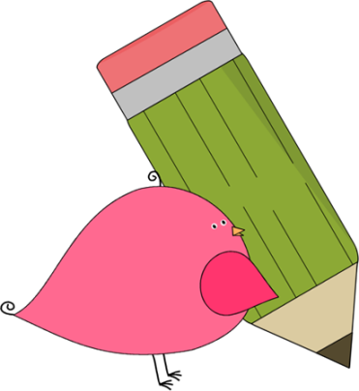

3rd Grade Happenings

October 10th, 2014





In class this week:

**Math:** We finished our subtraction unit and have moved on into measurement. In the next two weeks we will look at both metric and standard measurement.

**Writing:** We’re diving into personal narratives head first!So far we’ve generated story ideas, talked about leads, and picked one story to focus on. Next week we’ll take a look at a mentor text to see what makes it so good. We’ll try to incorporate some of those techniques into our own writing.

From Mrs. Hunter:

It was absolutely wonderful to see so many grandparents today! We had a lot of laughs and made many great memories.

As the temperature gets cooler, please remember to send your child to school with a coat. We still go out to recess as long as it’s not raining.

Thanks for bringing in 2 liter bottles. We hope you enjoy your rain gauge!

At this point we are about halfway through the trimester. If you have any questions about your child’s progress feel free to contact me. I don’t want you to feel out of the loop!



Important Dates and Upcoming Events:

* Oct 20: Fundraiser packets due.
* Oct 23: School Picture Retakes
* Oct 31: Halloween Parade/Party 1:30
* Nov 3: PTA Mtg @ 6
* Nov 4: No School (Teacher Workday)



Want to know more?

Check out our class blog and website!

Website: Mrshuntertmp.weebly.com

Blog: Mrshuntertmp.blogspot.com