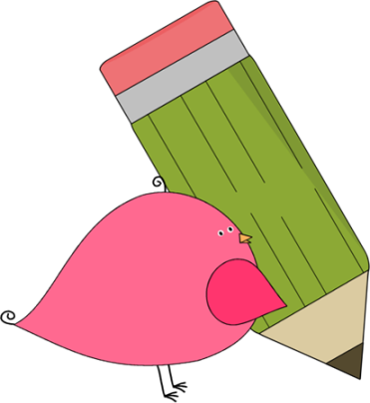

3rd Grade Happenings

November 7th, 2014





In class this week:

**Writing:** Our children’s books are now finished. Now off to share them with the Prairie pups before sending them home.

**Math**: Duh, duh, dummmmm! Welcome to multiplication! It’s hard to believe that we’re ready for such a fun and engaging (although somewhat challenging) topic. ☺ We’re starting out slow and looking at multiplication as repeated addition and have not introduced the algorithm. For example, we’re looking at 3+3+3 instead of 3 X 2. We’ll teach the algorithm soon but want children to first have an understanding that multiplication is really just addition.

From Mrs. Hunter:

Oh my goodness!! It is hard to believe that the 1st trimester is already done and 1/3 of my time with these wonderful students is already finished. We’ve learned so much but still have so much to do!

Brrr…it’s getting cold and windy on the Prairie! Please encourage your child to bring a jacket and wear it during recess. I’ll do the same! ☺

Please remember to be filling out the reading log daily. We still have several students that have not turned their log in from last month.

If you have any spare ear buds around the house we have a few students who are still in need of them.



Important Dates and Upcoming Events:

* Nov 4: No School (Teacher Workday)
* Nov 13-14: Parent/Teacher Conferences
* Nov 14: No School



Want to know more?

Check out our class blog and website!

Website: Mrshuntertmp.weebly.com

Blog: Mrshuntertmp.blogspot.com