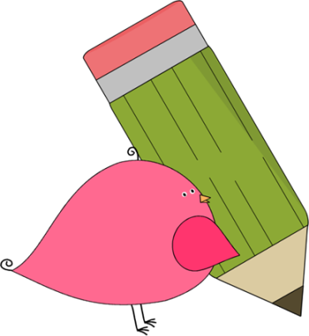

3rd Grade Happenings

November 21st, 2014





In class this week:

**Writing:** This week we’ve been practicing our cursive, learning some new Daily 5 choices, and reading our stories to the Prairie Pups (pictures soon to come on the blog). After Thanksgiving we’ll start work on Informational writing.

**Health:** Our focus in health this week was on two types of germs: bacteria and viruses. We learned about each one individually and then used a Venn diagram to show how they were alike and different. We look forward to combining our health unit with writing when we start informational writing. It’s been a fascinating topic thus far!

From Mrs. Hunter:

It was so fabulous seeing everyone at conferences this past week. Feel free to contact me if you have any lingering questions.

Special thanks to those that donated food for our conference meal. I have been told that there were no business donations. Wow!! Here are the names I was given: Becca Abadi, Rebecca Childers, Kellie Dennis, Stacey Spinks, Melissa Jenkins, Melissa Moore, Kelly Lamb, Amy Adam, Angie Acton, Denise Banks Thomas , Lisa Ozanich, Jessica Bedford, Jennifer Bolton, Michelle Hall. THANK YOU!!!



Important Dates and Upcoming Events:

* Nov. 26-28: Thanksgiving Break
* Dec. 19: Winter Parties @ 1:30
* Dec 22- Jan 2: Winter Break
* Jan. 19: No School (MLK day)



Want to know more?

Check out our class blog and website!

Website: Mrshuntertmp.weebly.com

Blog: Mrshuntertmp.blogspot.com