

3rd Grade Happenings

May 8th, 2015

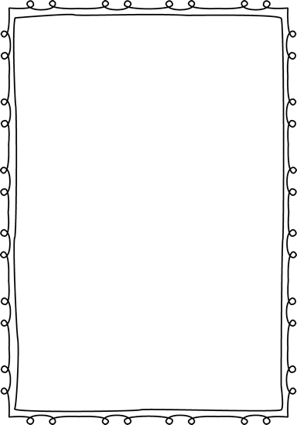



In class this week:

**Science:** We started a new unit in science this week, Force and Motion. So far we’ve defined these terms and done two experiments with them. This is very hands on unit and will culminate with a force and motion carnival the last full week of school.

**Math:** We’ve made our way back to our big text book to review what we’ve learned already about fractions. I’m amazed to see how quickly the students are picking the concepts up. We’ve talked about several different ways a whole can be broken up and done a few hands on activities as a class. This unit will take us up to the end of the year.

From Mrs. Hunter:

Today was a great day!! We got to have huge celebration in honor of Ms. Castino’s last day. She has been a great help to us and it was great to see the students so appreciative of all she does for us. She’s sure to be a great teacher!

It’s great to see the kiddos so focused, especially so close to the end of the year. They amaze me every day. ☺



Important Dates and Upcoming Events:

* May 25: Memorial Day
* June 3rd—Last day of school (Field Day)



Want to know more?

Check out our class blog and website!

Website: Mrshuntertmp.weebly.com

Blog: Mrshuntertmp.blogspot.com