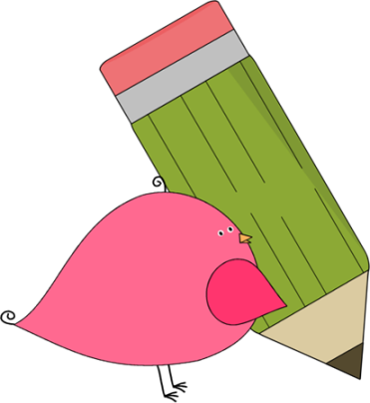

3rd Grade Happenings

March 6th, 2015

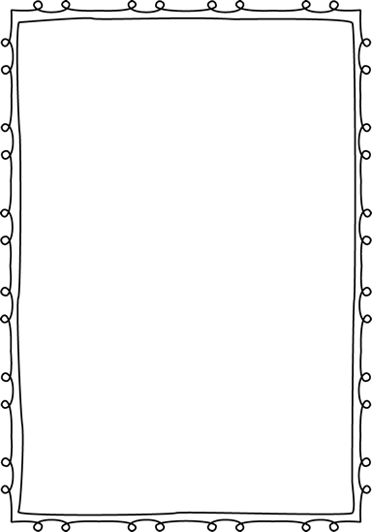



In class this week:

**Writing:** Our biography projects are finished and we’ve moved on to opinion writing. We started this unit with a study of Oreos!! We examined them using our sense and will come up with an opinion on them next week. Writing never tasted so good!

**Math:** Keep practicing those math facts!! We’ve been working hard to earn our sundae toppings. Our top earners have a bowl, spoon, and napkin. We’ve moved away from multiplication and division and have been working on geometry the past few weeks. We’ve been drawing and classifying polygons, triangles, and quadrilaterals.

From Mrs. Hunter:

Another great week in 3rd grade. We seem to be getting on the right track in terms of getting our work done and staying focused. We’ve all got our eyes on the prize, the learning of valuable information!

I really enjoyed seeing everyone at conferences! It’s so great to talk to you in person about the wonderful things your children are doing. Please talk to me to reschedule if you haven’t met with me yet.

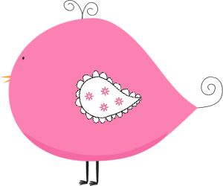

Important Dates and Upcoming Events:

* March 23-27: Spring Break
* May 1: Picnic on the Prairie 5:30-7:30
* May 25: Memorial Day
* June 3rd—Last day of school

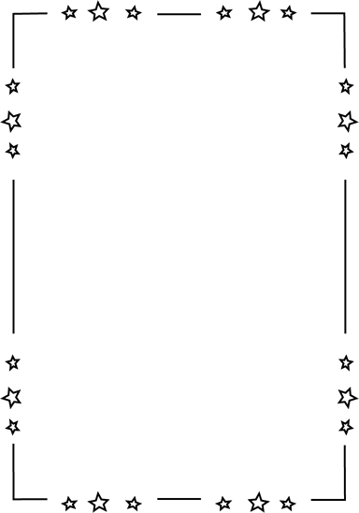

Want to know more?

Check out our class blog and website!

Website: Mrshuntertmp.weebly.com

Blog: Mrshuntertmp.blogspot.com