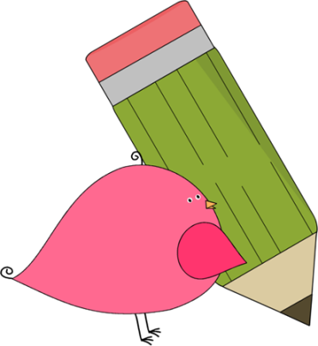

3rd Grade Happenings

March 13th, 2015

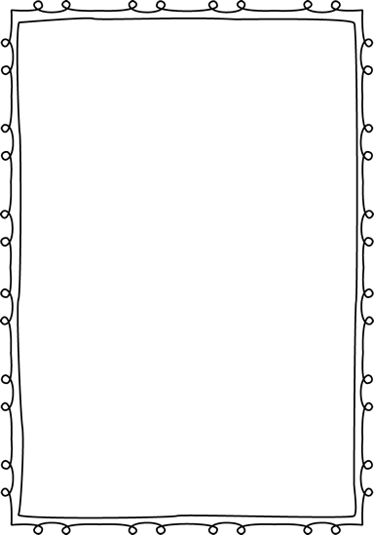



In class this week:

**Writing:** Opinion writing is in full force!! We’ve had a great time picking topics we truly care about and trying to convince others of our thoughts. This is a fun unit that the students seem to really enjoy!

**Science:** Thank you to those that have already brought in materials for our habitat diorama! In case you are unaware, each student is a part of a group creating a habitat. They’ve already planned it out and should be aware of what materials are needed.

**Math:** We’ve moved from geometry to area, perimeter, and volume. This has proved to be a bit more difficult. Keep practicing those facts!

From Mrs. Hunter:

Can you believe this weather!? It’s been absolutely beautiful and we’re definitely enjoying ourselves in 3rd grade.

Please be sure to check over your child’s homework every night. Several students are coming back to school having nothing done and it’s starting to become a problem. Please contact me if you need help in any way. That’s what I’m here for!



Important Dates and Upcoming Events:

* March 23-27: Spring Break
* May 1: Picnic on the Prairie 5:30-7:30
* May 25: Memorial Day
* June 3rd—Last day of school



Want to know more?

Check out our class blog and website!

Website: Mrshuntertmp.weebly.com

Blog: Mrshuntertmp.blogspot.com