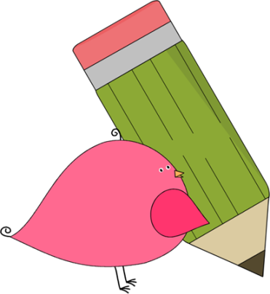

3rd Grade Happenings

February 6th, 2015





In class this week:

**Writing:** We put our informational writing skills to good use this week with a new project, Biographies! We picked our topic and did research this week. Next week we’ll decide on our main ideas and write our paragraphs.

**Math:** Division started up this week and was a bit more difficult than anticipated. We took loads of extra time to work through separating into equal groups and remainders. We’re getting a better handle of it now and will continue working on it for a few more weeks.

**Science:** Stay tuned for more information about our new ecosystem unit!

From Mrs. Hunter:

Flexibility has been the name of the game this week! With special counselor lessons, plenty of snow days/late starts, and a new project in writing, we’ve had a lot to keep track of. I’m proud of their consistency and hard work.

The rigor of 3rd grade has really set in! I’m impressed by how many students have risen to the occasion but know we always have lots of room for improvement. We have had some difficulties reading all the way through problems and really giving our best effort. Please continue to encourage these behaviors at home.



Important Dates and Upcoming Events:

* Feb. 12: Valentine’s Day Parties @1:30pm
* Feb. 13: No School (Teacher Workday)
* Feb. 16 No School (President’s Day)
* Feb 26-27: Parent Teacher Conferences



Want to know more?

Check out our class blog and website!

Website: Mrshuntertmp.weebly.com

Blog: Mrshuntertmp.blogspot.com