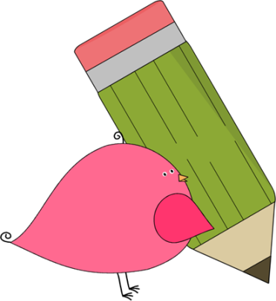

3rd Grade Happenings

February 20th, 2015

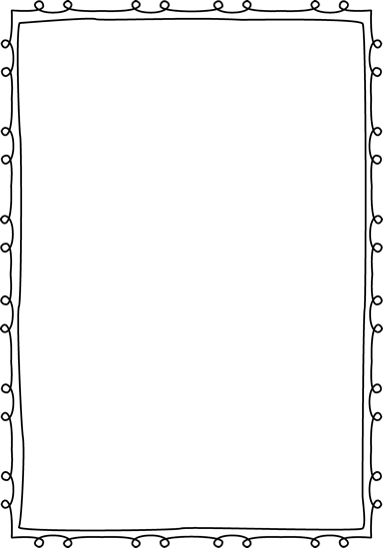



In class this week:

**Writing:** We have been hard at work researching our famous person for our biography project. Next week we’ll start typing using Google Drive!

**Math:** We finished up our study of multiplication and division this week. Keep practicing those facts at home. We’re starting a new incentive program where students will earn part of an ice cream sundae for each set of facts they know.

**Science:** Our ecosystem unit started off with a bang! We discussed living and nonliving objects as well as food chains. The highlight was making a bottle ecosystem complete with living plants and animals! We’ll continue to study those over the next few weeks.

From Mrs. Hunter:

I saw a great deal and focus from my 3rd graders this week which most definitely put a smile on my face! It’s wonderful to see them growing up before my very eyes.

Please be sure to be checking your child’s homework every night. Several students are in a pattern or forgetting their homework or not doing their best on it. It’s imperative that each child works hard at home and at school to learn the subject material. I know that they are very capable but the 3rd trimester of 3rd grade can be really tricky. Let’s all hang in there and work together!



Important Dates and Upcoming Events:

* Feb 26-27: Parent Teacher Conferences
* March 23-27: Spring Break
* May 25: Memorial Day
* June 3rd—Last day of school



Want to know more?

Check out our class blog and website!

Website: Mrshuntertmp.weebly.com

Blog: Mrshuntertmp.blogspot.com