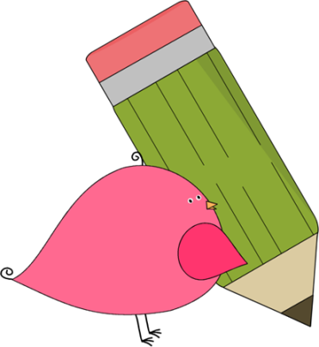

3rd Grade Happenings

April 24th, 2015

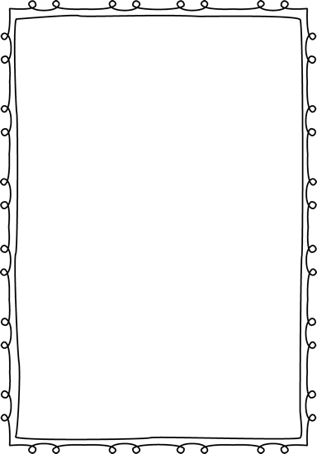



In class this week:

**Writing:** We took opinion writing to the next level this week! We formatted our work into a series of paragraphs and discussed what each paragraph should contain. This was a big step and I was impressed with their hard work.

**Math:** We continued to learn about fractions this week, specifically what smaller fractions make up larger fractions. We used handmade fraction cards as a visual and they really helped out. Be sure to continue practicing those multiplication facts at home. We want to make sure everyone gets at least one scoop of ice cream and to do this they must past their 4’s test.

From Mrs. Hunter:

Thank you to everyone that got a chance to come for our Brownbag Lunch. I know the students just loved showing off all of their projects to you. They worked very hard to do their very best work.

As the year is winding down, please remember to be checking over your child’s homework every night. It seems like some of this has slipped to the wayside at this point.



Important Dates and Upcoming Events:

* May 1: Picnic on the Prairie 5:30-7:30
* May 25: Memorial Day
* June 3rd—Last day of school

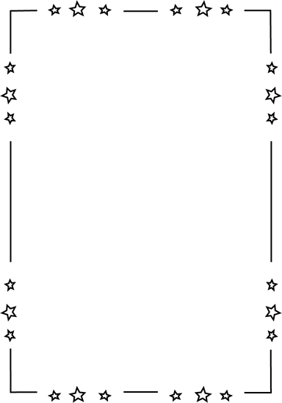

Want to know more?

Check out our class blog and website!

Website: Mrshuntertmp.weebly.com

Blog: Mrshuntertmp.blogspot.com