

3rd Grade Happenings

April 17th, 2015

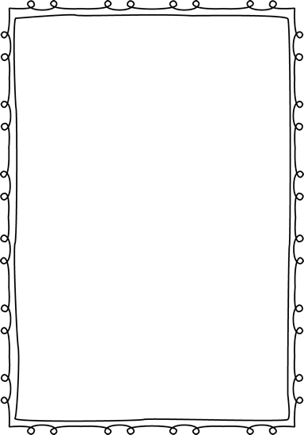



In class this week:

**Writing:** This week we expanded our opinion pieces a bit. We continue to use our format of OREO (Opinion, Reason, Examples, restate Opinion) but extended our examples a bit. Students are now expected to turn their examples into paragraphs when working on opinion pieces.

**Social Studies:** Our economics unit is coming along nicely. This week we discussed goods, services, private and public goods, and taxes. This unit is such a great opportunity for students to gain an understanding of how the economy works on a local scale. They have been very engaged and excited to learn all they can.

From Mrs. Hunter:

MAP testing is officially OVER!! I am so impressed with the hard work of all students. The test was challenging and being on computers was an extra obstacle but all students did well. I was especially impressed by the students’ stamina. Some students tested for almost two hours without choosing to take a break. Wow!

Please return your Brown Bag Lunch permission forms if you haven’t already.



Important Dates and Upcoming Events:

* May 1: Picnic on the Prairie 5:30-7:30
* May 25: Memorial Day
* June 3rd—Last day of school



Want to know more?

Check out our class blog and website!

Website: Mrshuntertmp.weebly.com

Blog: Mrshuntertmp.blogspot.com