

3rd Grade Happenings

April 10th, 2015

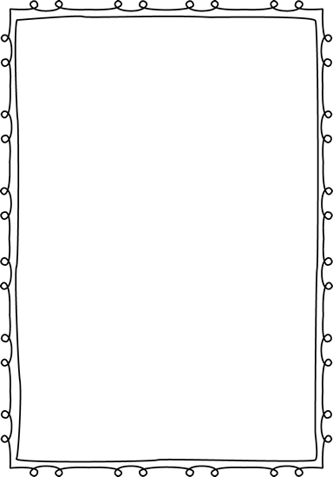



In class this week:

**Writing:** This week writing was dedicated to practicing for the MAP test. This year the test will be entirely online which comes with its own unique set of challenges. I am confident that all students can do well. Please make sure your child shows up on time next week after having a good night’s sleep and great breakfast.

**Social Studies:** We started a new unit this week dedicated to economics. So far we’ve discussed abundance, scarcity, and opportunity cost. These ideas are review and students have picked them up nicely.

From Mrs. Hunter:

Some exciting news went out in Friday folders this week! We are so excited to be able to invite you to our classroom for a brown bag lunch to show off our amazing Ecosystem projects. Please return the note by next Friday so we know how many to expect.

Thank you so much for all the well wishes regarding my pregnancy! You and your children are so sweet!



Important Dates and Upcoming Events:

* May 1: Picnic on the Prairie 5:30-7:30
* May 25: Memorial Day
* June 3rd—Last day of school



Want to know more?

Check out our class blog and website!

Website: Mrshuntertmp.weebly.com

Blog: Mrshuntertmp.blogspot.com